**English**

2nd year

1. **VERBS: Select the verbs from the WORD BANK and match them with the pictures. Write the verbs in the boxes.**

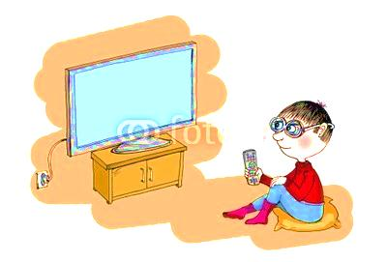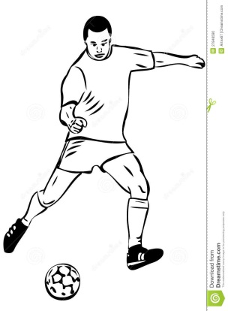

***Ex: reading***

**WORD BANK**

|  |  |  |
| --- | --- | --- |
| shopping | eating | sitting |
| ~~reading~~ | smiling | singing |
| writing | sleeping | drinking |
| running | working | dancing |
| walking | watching TV | playing |

Choose 10 verbs and use them in full sentences.

1-______________________________________________________

2-______________________________________________________

3-______________________________________________________

4-______________________________________________________

5-______________________________________________________

1. **Unscramble the questions. Then match them to the correct answer using numbers.**

1 name / What / your / ’s / first ***(Example)***

***Whats’s your first name***?

2 your / surname / ’s / What

?

3 do / it / How / spell / you

?

4 are / old / How / you

?

5 in / What / you / class / are

?

[ ] A-D-K-I-N-S

[ ] 2 B

[***1*** ] Adele ***Example***

[ ] 14

[ ] Adkins

1. **Rewrite the sentences using a personal pronoun. Follow the example.**

***Example: Marta is very intelligent.***

***She is very intelligent.***

1 Your MP4 player is fantastic!

2 Henry and I are on the school tennis team.

3 The boys in my class aren’t funny.

4 Jim Carrey is my favourite actor.

5 Laura and her friends are very nice.